***C++ PROGRAM LAB TASK 4 WITH SOLUTIONS***

1. **Write a program in C++ to show the simple structure of a function?**

**#include <iostream>**

**using namespace std;**

**int sum (int a, int b);**

**class fun**

**{**

**public:**

**int total;**

**};**

**int main ()**

**{**

**//function declaration**

**fun f;**

**cout<<"\n\n Function : a simple structure of function :\n";**

**cout<<"------------------------------------------------\n";**

**f.total =sum (21,171);//function call**

**cout<<"The total is :"<<f.total;**

**return 0;**

**}**

**int sum (int a, int b) //function definition**

**{**

**int s;**

**s=a+b;**

**return s; //function returning a value**

**}**

**OUTPUT:**

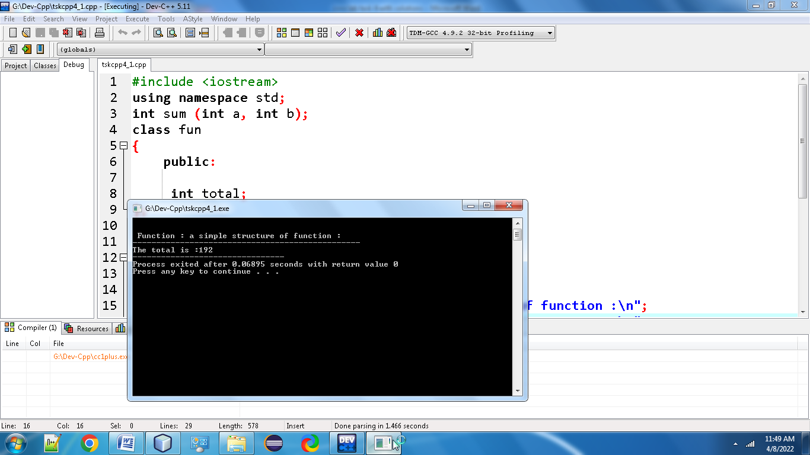

**2.Write a program in C++ to find the square of any number using the function.?**

**#include<iostream>**

**using namespace std;**

**class sq**

**{**

**public:**

**int num;**

**double n;**

**};**

**double square(double num)**

**{**

**return (num * num);**

**}**

**int main()**

**{**

**sq s;**

**cout<<"\n\n Function : find square of any number :\n";**

**cout<<"------------------------------------------------\n";**

**cout<<"Input any number for square : ";**

**cin>>s.num;**

**s.n = square(s.num);**

**cout<<"The square of "<<s.num<<" is :\n"<<s.n;**

**return 0;**

**}**

**Output:**

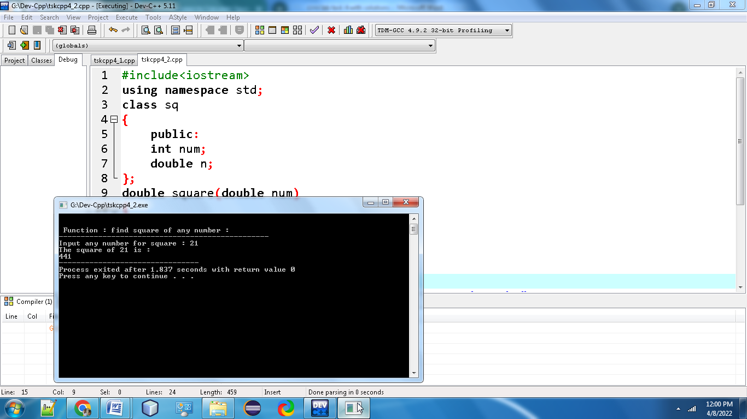

**3.Write a program in C++ to swap two numbers using function?**

 #include<iostream>

using namespace std;

class swp

{

public:

int a,b;

};

void swap(int a,int b );

int main()

{

swp sp;

cout<<"Enter the Two Numbers to Swap in C++: ";

cin>>8sp.a>>sp.b;

cout<<"\nAfter Swapping of Two Numbers:";

swap(sp.a,sp.b);

return 0;

}

void swap(int x,int y)

{

int z;

z=x;

x=y;

y=z;

cout<<" "<<x<<" "<<y;

}

Output:

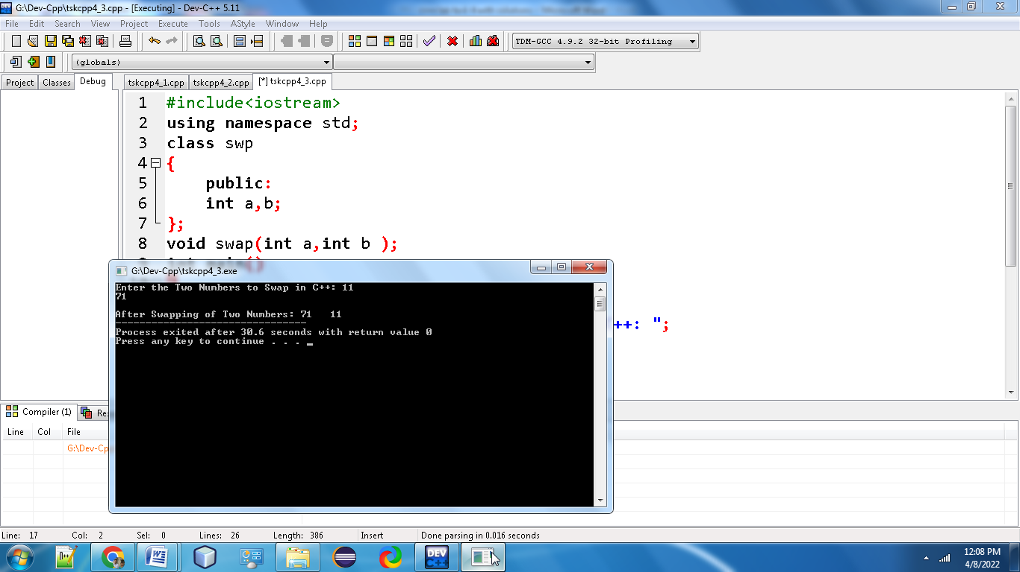

**4.Write a program in C++ to check a given number is even or odd using the function?**

#include <iostream>

using namespace std;

class oe

{

public:

int n1;

};

int checkOddEven(int n1)

{

return (n1 & 1);

}

int main()

{

oe o;

cout<<"\n\n Function : check the number is even or odd:\n";

cout<<"------------------------------------------------\n";

cout<<"Input any number :";

cin>>o.n1;

if(checkOddEven(o.n1))

{

cout<<"The entered number is odd.\n\n";

}

else

{

cout<<"The entered number is even.\n\n";

}

return 0;

}

**Output:**

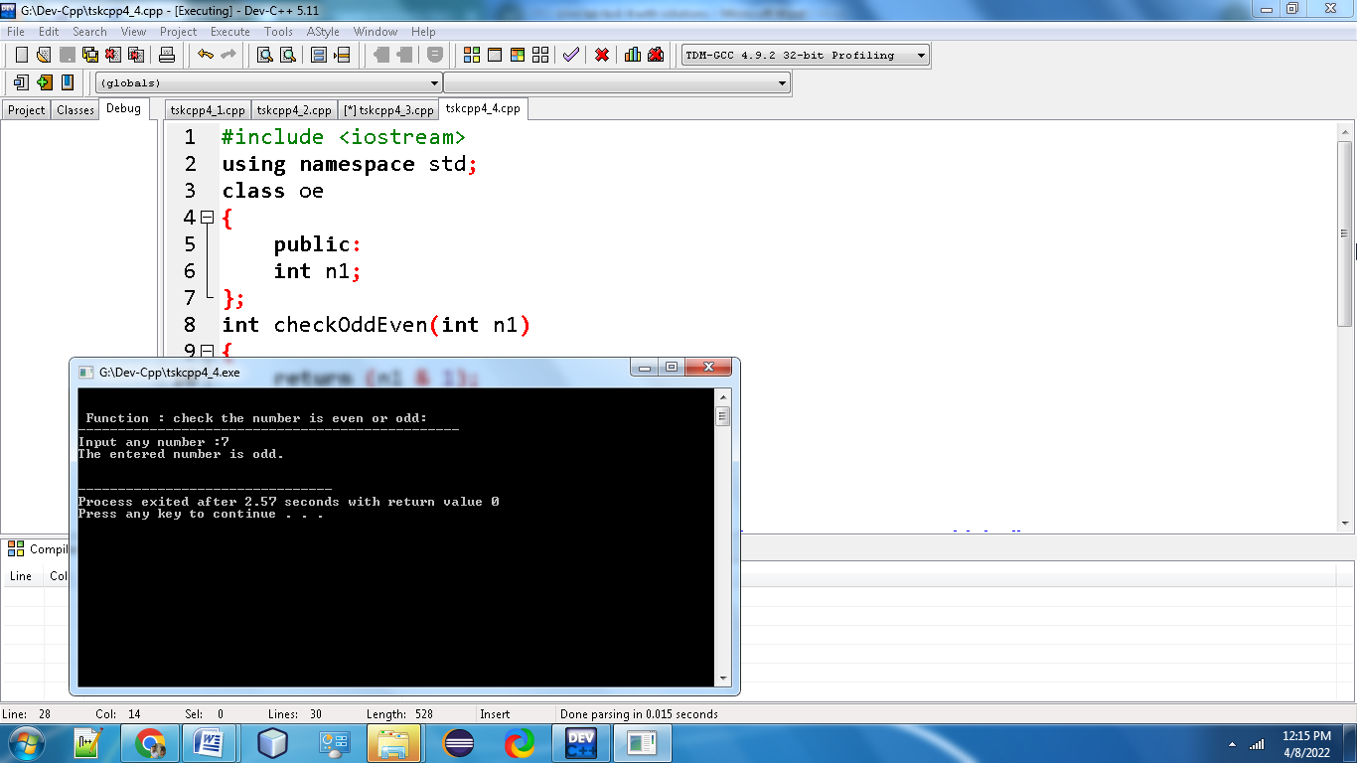

**5. Write a program in C++ to find the sum of the series 1!/1+2!/2+3!/3+4!/4+5!/5 using the function.**

**#include <iostream>**

**using namespace std;**

**class fac**

**{**

**public:**

**int sum;**

**};**

**int fact(int);**

**int main()**

**{**

**fac f;**

**f.sum=fact(1)/1+fact(2)/2+fact(3)/3+fact(4)/4+fact(5)/5;**

**cout<<"\n\n Function : find the sum of 1!/1+2!/2+3!/3+4!/4+5!/5 :\n";**

**cout<<"----------------------------------------------------------\n";**

**cout<<"The sum of the series is :\n\n"<<f.sum;**

**return 0;**

**}**

**int fact(int n)**

**{**

**int num=0,f=1;**

**while(num<=n-1)**

**{**

**f =f+f*num;**

**num++;**

**}**

**return f;**

**}**

**Output:**

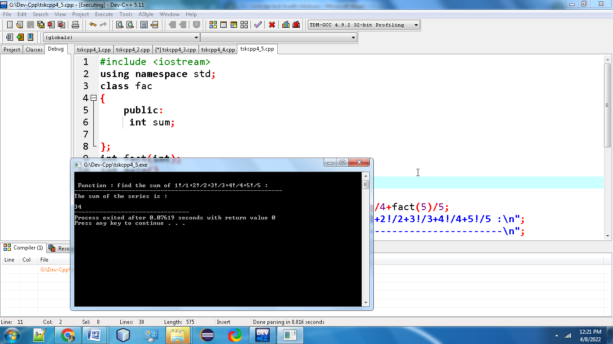

**6. Write a program in C++ to convert decimal number to binary number using the function?**

**#include <iostream>**

**using namespace std;**

**class bin**

**{**

**public:**

**long decimal;**

**};**

**long decimalToBinary(long n);**

**int main() {**

**bin b;**

**cout <<"Enter a decimal number\n";**

**cin >> b.decimal;**

**cout << "Binary number = " << decimalToBinary(b.decimal);**

**return 0;**

**}**

**// Function to convert a decinal number to binary number**

**long decimalToBinary(long n) {**

**int remainder;**

**long binary = 0, i = 1;**

**while(n != 0) {**

**remainder = n%2;**

**n = n/2;**

**binary= binary + (remainder*i);**

**i = i*10;**

**}**

**return binary;**

**}**

**Ouput:**

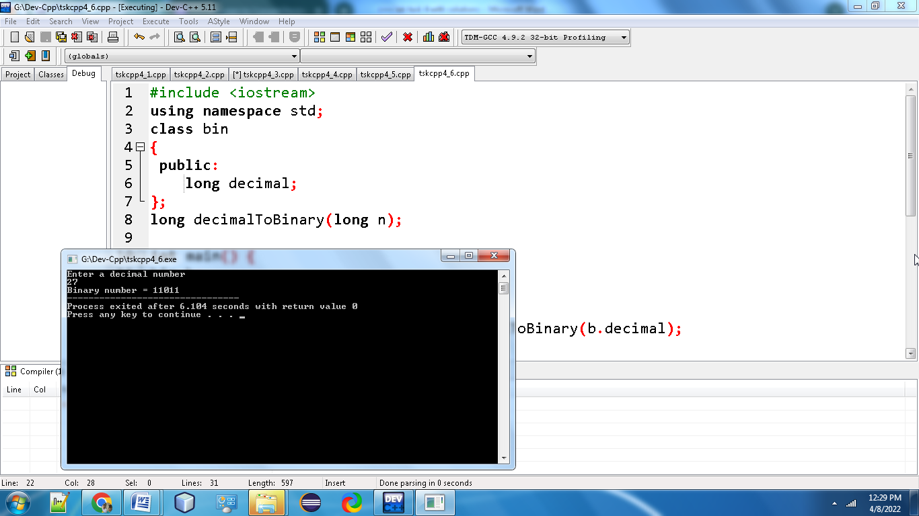

**7. Write a program in C++ to check whether a number is a prime number or not using the function?**

**#include<iostream>**

**using namespace std;**

**class pri**

**{**

**public:**

**int n1,prime;**

**};**

**int PrimeOrNot(int);**

**int main()**

**{**

**pri p;**

**cout<<"\n\n Function : check whether a number is prime number or not :\n";**

**cout<<"---------------------------------------------------------------\n";**

**cout<<" Input a positive number : ";**

**cin>>p.n1;**

**p.prime = PrimeOrNot(p.n1);**

**if(p.prime==1)**

**cout<<" The number "<<p.n1<<" is a prime number.\n";**

**else**

**cout<<" The number "<<p.n1 <<" is not a prime number.\n";**

**return 0;**

**}**

**int PrimeOrNot(int n1)**

**{**

**int i=2;**

**while(i<=n1/2)**

**{**

**if(n1%i==0)**

**return 0;**

**else**

**i++;**

**}**

**return 1;**

**}**

**Output:**

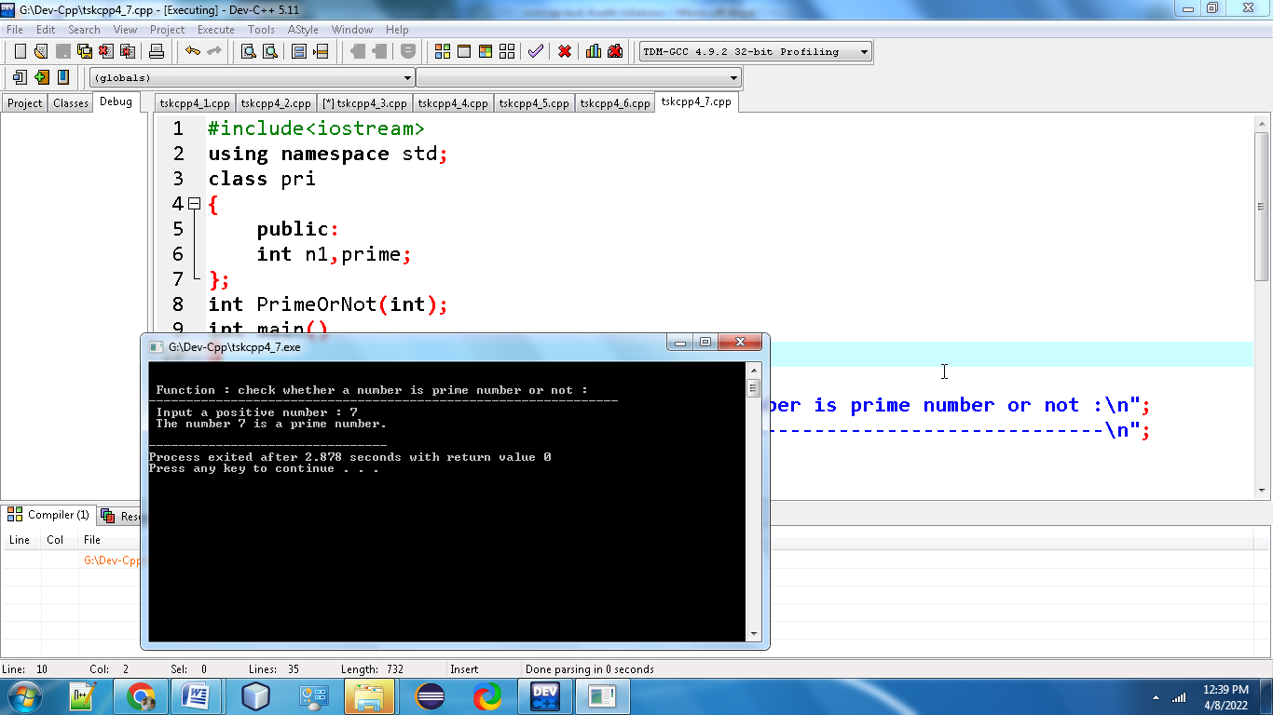

**8.Write a program in C++ to get the largest element of an array using the function?**

**#include <iostream>**

**using namespace std;**

**class mx**

**{**

**public:**

**int i, n;**

**float arr[100];**

**};**

**int main() {**

**mx m;**

**cout << "Enter total number of elements(1 to 100): ";**

**cin >>m.n;**

**cout << endl;**

**for(m.i = 0; m.i < m.n; ++m.i) {**

**cout << "Enter Number " << m.i + 1 << " : ";**

**cin >>m. arr[m.i];**

**}**

**for(m.i = 1;m.i <m. n; ++m.i) {**

**if(m.arr[0] < m.arr[m.i])**

**m.arr[0] =m.arr[m.i];**

**}**

**cout << endl << "Largest element = " << m.arr[0];**

**return 0;**

**}**

**Output:**

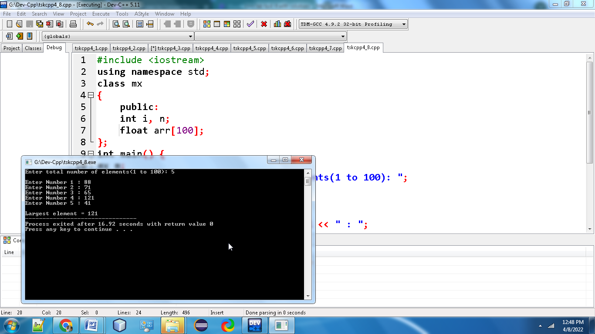

**9. Write a program in C++ to check Armstrong and perfect numbers using the function?**

**#include <iostream>**

**using namespace std;**

**class amper**

**{**

**public:**

**int n1;**

**};**

**int checkArmstrong(int n1);**

**int checkPerfect(int n1);**

**int main()**

**{**

**amper a;**

**cout<<"\n\n Function : check Armstrong and perfect numbers :\n";**

**cout<<"-----------------------------------------------------\n";**

**cout<<" Input any number: ";**

**cin>>a.n1;**

**if(checkArmstrong(a.n1))**

**{**

**cout<<" The"<<a.n1<<" is an Armstrong number.\n";**

**}**

**else**

**{**

**cout<<"The"<<a.n1<<"is not an Armstrong number.\n";**

**}**

**if(checkPerfect(a.n1))**

**{**

**cout<<"The"<<a.n1<<" is a Perfect number.\n\n";**

**}**

**else**

**{**

**cout<<" The"<<a.n1<<" is not a Perfect number.\n\n";**

**}**

**return 0;**

**}**

**int checkArmstrong(int n1)**

**{**

**int ld, sum, num;**

**sum = 0;**

**num = n1;**

**while(num!=0)**

**{**

**ld = num % 10;**

**sum += ld * ld * ld;**

**num = num/10;**

**}**

**return (n1 == sum);**

**}**

**int checkPerfect(int n1)**

**{**

**int i, sum, num;**

**sum = 0;**

**num = n1;**

**for(i=1; i<num; i++)**

**{**

**if(num%i == 0)**

**{**

**sum += i;**

**}**

**}**

**return (n1 == sum);**

**}**

**Ouput:**

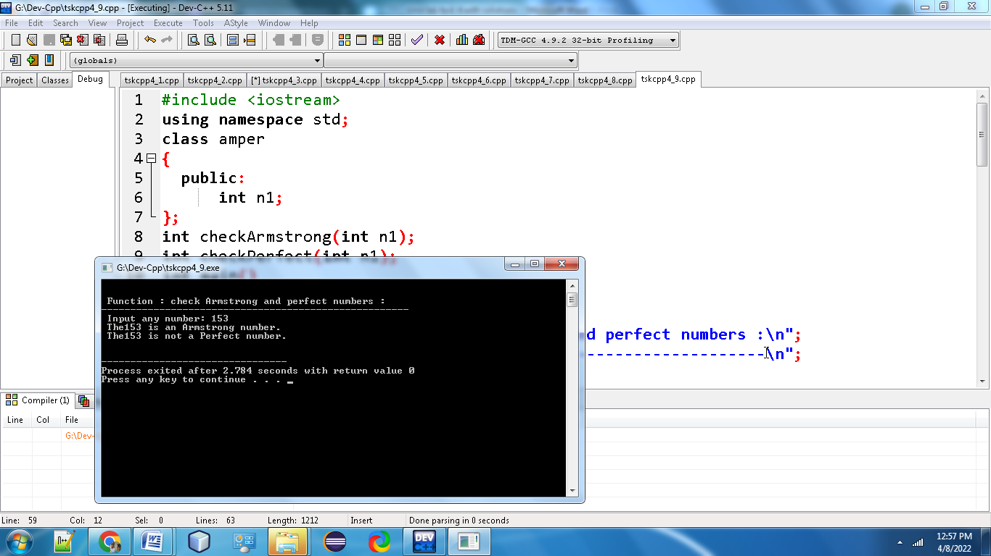

**10.Write a program in C++ to print all perfect numbers in given range using the function?**

**#include <iostream>**

**using namespace std;**

**class per**

**{**

**public:**

**int stLimit, enLimit;**

**};**

**int checkPerfect(int n1);**

**void PerfectNumbers(int stLimit, int enLimit);**

**int main()**

**{**

**per p;**

**cout<<"\n\n Function : perfect numbers in a given range :\n";**

**cout<<"--------------------------------------------------\n";**

**cout<<" Input lowest search limit of perfect numbers : ";**

**cin>>p.stLimit;**

**cout<<" Input highest search limit of perfect numbers : ";**

**cin>>p.enLimit;**

**cout<<"\n The perfect numbers between"<<p.stLimit<<" to"<<p.enLimit<<" are : \n";**

**PerfectNumbers(p.stLimit, p.enLimit);**

**cout<<"\n\n";**

**return 0;**

**}**

**int checkPerfect(int n1)**

**{**

**int i, sum;**

**sum = 0;**

**for(i=1; i<n1; i++)**

**{**

**if(n1 % i == 0)**

**{**

**sum += i;**

**}**

**}**

**if(sum == n1)**

**return 1;**

**else**

**return 0;**

**}**

**void PerfectNumbers(int stLimit, int enLimit)**

**{**

**while(stLimit <= enLimit)**

**{**

**if(checkPerfect(stLimit))**

**{**

**cout<<stLimit<<"\n";**

**}**

**stLimit++;**

**}**

**}**

**Output:**

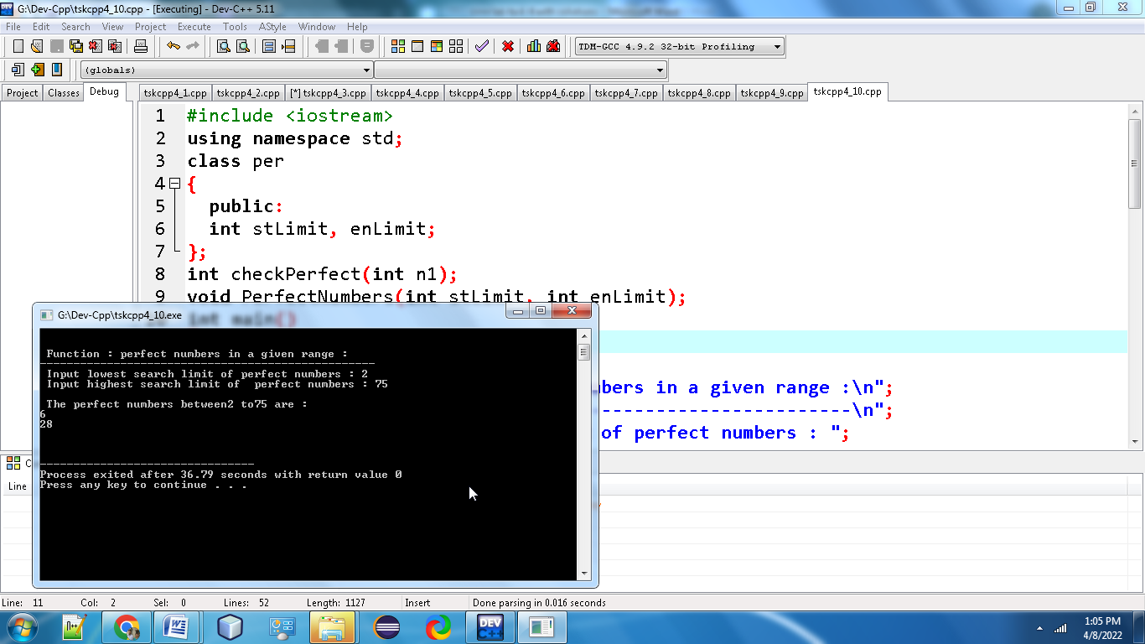

**11. Write a program in C++ to check whether two given strings are an anagram.**

**#include<iostream>**

**#include<string.h>**

**using namespace std;**

**class anagram**

**{**

**public:**

**char str1[20], str2[20];**

**int len1, len2, i, j, found=0, not_found=0;**

**};**

**int main()**

**{**

**anagram ag;**

**cout<<"Enter the First String: ";**

**cin>>ag.str1;**

**cout<<"Enter the Second String: ";**

**cin>>ag.str2;**

**ag.len1 = strlen(ag.str1);**

**ag.len2 = strlen(ag.str2);**

**if(ag.len1 == ag.len2)**

**{**

**for(ag.i=0; ag.i<ag.len1; ag.i++)**

**{**

**ag.found = 0;**

**for(ag.j=0; ag.j<ag.len1; ag.j++)**

**{**

**if(ag.str1[ag.i] == ag.str2[ag.j])**

**{**

**ag.found = 1;**

**break;**

**}**

**}**

**if(ag.found == 0)**

**{**

**ag.not_found = 1;**

**break;**

**}**

**}**

**if(ag.not_found == 1)**

**cout<<"\nStrings are not Anagram";**

**else**

**cout<<"\nStrings are Anagram";**

**}**

**else**

**cout<<"\nCharacter count Mismatched!";**

**cout<<endl;**

**return 0;**

**}**

**OUTPUT:**

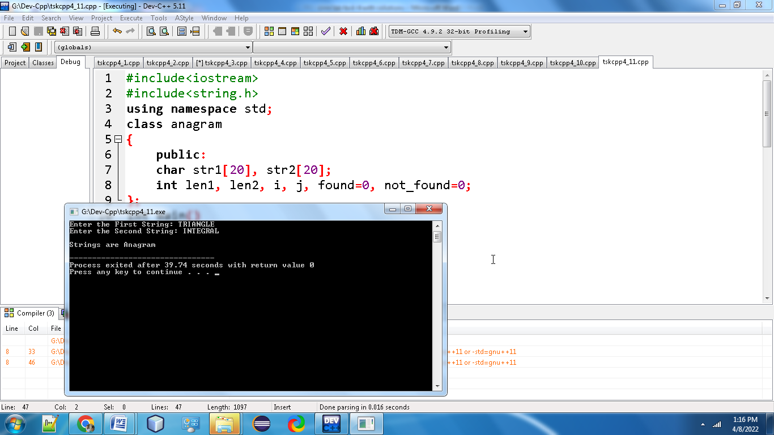

**12.Write a C++ programming to find out maximum and minimum of some values using function which will return an array?**

**#include <iostream>**

**using namespace std;**

**#define SIZE 50**

**class mm**

**{**

**public:**

**int array[SIZE];**

**int i, max, min, size;**

**};**

**int main()**

**{**

**mm m;**

**cout<<"Enter size of the array: ";**

**cin>>m.size;**

**cout<<"\n Enter "<<m.size <<" elements in the array: ";**

**for(m.i=0; m.i<m.size; m.i++)**

**cin>>m.array[m.i];**

**m.max = m.array[0];**

**m.min = m.array[0];**

**//Find maximum and minimum in all array elements.**

**for(m.i=1; m.i<m.size; m.i++)**

**{**

**// If current element is greater than max**

**if(m.array[m.i] > m.max)**

**m.max = m.array[m.i];**

**// If current element is smaller than min**

**if(m.array[m.i] < m.min)**

**m.min = m.array[m.i];**

**}**

**// Print maximum and minimum element**

**cout<<"\nMaximum element =" << m.max << "\n";**

**cout<<"Minimum element =" << m.min;**

**return 0;**

**}**

**Output:**

